**Requirement:** A tool that allows Enterprise customers to test their network for incompatibilities with SR DNA Enterprise. The tool should be runnable everywhere and would give the user a report of potential network incompatibilities that would prevent SR DNA to leverage its full power.

1. **Who would benefit from this feature? What problem does it solve? What values does it bring to SR and/or its customers?**
2. **Existing and Potential customers** – they will be able to better leverage SR DNA after finding network compatibility issues. Potential customers can quickly test and estimate the effort required (to make their network compatible to use SR DNA).
3. **Customers who might have rejected SR earlier** – because of network compatibility issues (because of their own network or of a CDN) which they could not decipher earlier.
4. The **SR Sales (or Operations) team** can use this tool to create a diagnostic report of the potential issues which such customers had and can re-approach them with a solution.
5. Similarly, this tool will also help the **SR customer tech support teams**: They will find it easier to find network compatibility issues (as one of the causes) and thus better solve customer issues.
6. **Marketing Team**: They have a new feature to present to the audience, which can be marketed smartly to generate leads.
7. **Product and Tech team**: Amongst all the issues the tool would present, there would be a theme (set of commonly occurring problems) with the various networks. Thus, the Prod and Tech team can work to make SR DNA compatible with those issues. In the long term, this will make the product more robust as well as increase customer confidence as SR DNA would be compatible with almost all the various networks.
8. Write down a list of functional requirements for the feature. You can categorize them as Nice to have / Should have / Must have. These requirements will be submitted to the engineering team to evaluate their feasibility and complexity and will then be used to write down a technical specification. Finally, they will be used by the QA team to validate the development.
   1. **Must Have**
      1. **Hardware and Software Compatibility Test**: Check if the SR DNA is compatible with the client hardware/software infrastructure (including the CDN they use). Is there any tool/hardware/software which the client uses and for which SR does not provide solutions?
      2. **Web players** – used by the client and the various web players supported by SR DNA
      3. **Firewall and Port blockages**: Check if the client network has a firewall which does not connect to external networks. Also, check for open ports or ports which should be kept open to connect with SR DNA
      4. **Streaming formats compatibility**: Supported by SR DNA against the streaming formats employed by the client
      5. Classify the issues as **“Necessary to be resolved”, “Good, if resolved” and “No effect”** – In the report created, these should be **color coded** to signify importance of the issue
      6. Provide **suitable solutions for commonly occurring problems**
      7. If possible, **provide cost and time effort calculator** for the changes to be made in the client network infrastructure to make it compatible with the SR DNA
   2. Should Have
      1. **Client Network Monitoring** – monitor client network infrastructure, and broadly display the additional cost/benefit effects of using SR DNA
      2. **Browser checks** – mainly for the end users of the client. Depending on the platform(s) of video consumption, make client recommendations
      3. **Geographical Suggestions**: Depending on the client’s geographical spread and accordingly the availability of infrastructure – provide recommendations to improve SR and client network’s performance.
   3. Nice to Have
      1. Suggestions to the client to **improve their network infrastructure** so that it performs better, irrespective of whether they use SR DNA or not
      2. Report about the **compatibility of other SR products apart from DNA** (this is basically a way of up-sell or future sale). Also, may prompt new ideas to establish relationship with the client.
9. Can it be broken down into several iterations?

Yes.   
**First iteration:** Go with, Must Haves: a(i), a(ii), a(iii) and a(iv) – these are the most important technical compatibility requirements without which SR DNA cannot be implemented with the client network.   
**Second Iteration:** Implement Must Haves: a(v), a(vi) and a(vii). These in addition to the feedback of the first iteration will add considerable value to the client

**Third Iteration:** Implement the Should Haves.

**Fourth Iteration:** Implement the Nice to haves.

Iterations and sprints can be configured depending on the resources available as well as the criticality of the requirement.

1. Provide a rough mock up for the interface (Click on the links to open the mock-ups in browser)   
   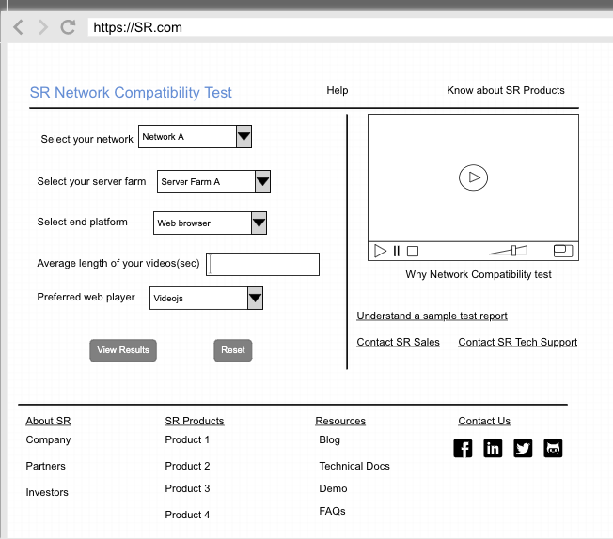

[Screen 1: Compatibility Test Interface](https://pidoco.com/rabbit/result/view/287319/page776652103/sketchedArial)  
  
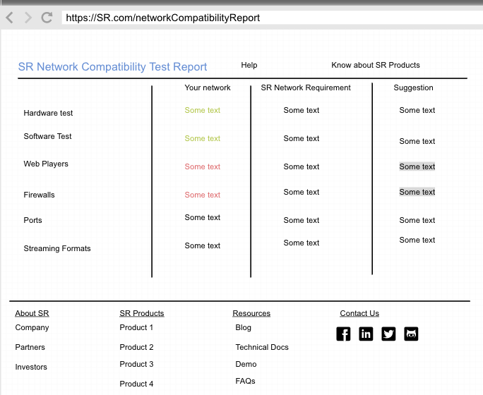

[Screen 2: Compatibility Test Report](https://pidoco.com/rabbit/result/view/287319/1177678544/sketchedArial)

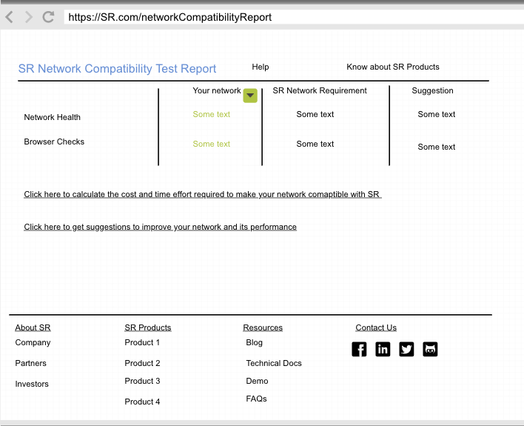

[Screen 3: Compatibility Test Report and Suggestions](https://pidoco.com/rabbit/result/view/287319/1893709041/sketchedArial)

1. Provide a short high-level product description of the tool/feature (that will be shared on the public documentation) as well as a brief technical documentation if need be.

**Product Description:**  
SR wants its customers to leverage the full power of SR DNA. Hence, SR wants to make sure that there are no network incompatibilities between your network and SR DNA.   
The simplest way to check this is to by using our Compatibility Tool – which runs a quick test (max 5 minutes) and generates a report which highlights the incompatibilities and areas where we need to work on to leverage the full power of SR DNA.   
  
To run the test:

1. Go [here](https://sr.com/compatibilityTest) or open the link <https://SR.com/compatibilityTest> in your browser window
2. Select your Network (the various available options will be automatically pre-fetched by our tool)
3. Select your Server Farm (the various available options will be automatically pre-fetched by our tool)
4. Select end platform for your user (Web, Android, iOS or Others)
5. Provide an average length of your videos (in seconds). You don’t have to be perfectly correct here. Though a good estimate will help us in providing better recommendations.
6. Select the preferred web player you use for your videos (for e.g. Videojs, Dash, HLS, Shaka, JW etc). We at SR cover almost all the web players available in the market. Still, in case there is something for which we do not provide service (or shown in the list here), please let us know and we will find a solution
7. Click on View Results

This will generate a report which will give you an overview of your network infrastructure and how compatible is it with SR DNA. You can have a rough idea of the time and cost effort involved in making changes to your network to make it compatible to SR DNA (this would be a rough estimate, and should not be considered final)  
It will also provide suggestions as to how to improve your network and its performance.

**Recommendations:**

1. **Documentation:**
   1. Videos: It is easier for the user to integrate code changes or work on any tool, if there is an explainer video. It is available in some cases, for e.g while adding a booklet marker but not at most places. A quick screen cast on the code changes to integrate with, for example, various web players would make it easier.
   2. Documentation is short and crisp and readily provides all the information needed. Addition of code (on github) and demo examples makes it easier to see what we are intending to do and follow it on the code. It is not a problem for a tech person, but I think a bit of an effort for a non-tech person and hence, videos would add a lot of value.
2. **Dashboard**:
   1. Again, I think a video or a quick guided tour would really help me in understanding the various sections and how to efficiently use the dashboard.
   2. It is quick to load, and does not hang up. It is very easy to use after you have spent some time on it.
   3. I think some common filters – such as dates, platforms, can be globally set up

(may be in the header) so that the user does not have to configure them every time he visits a different section.